Brian Santana

Linux Administration

**Lab 1 System Setup**

Installing Linux Os's are just as simple as installing windows os's and I’ll show you

When starting You must grab the ISO file from the ubuntu and centos website or whichever os you chose to install respectively

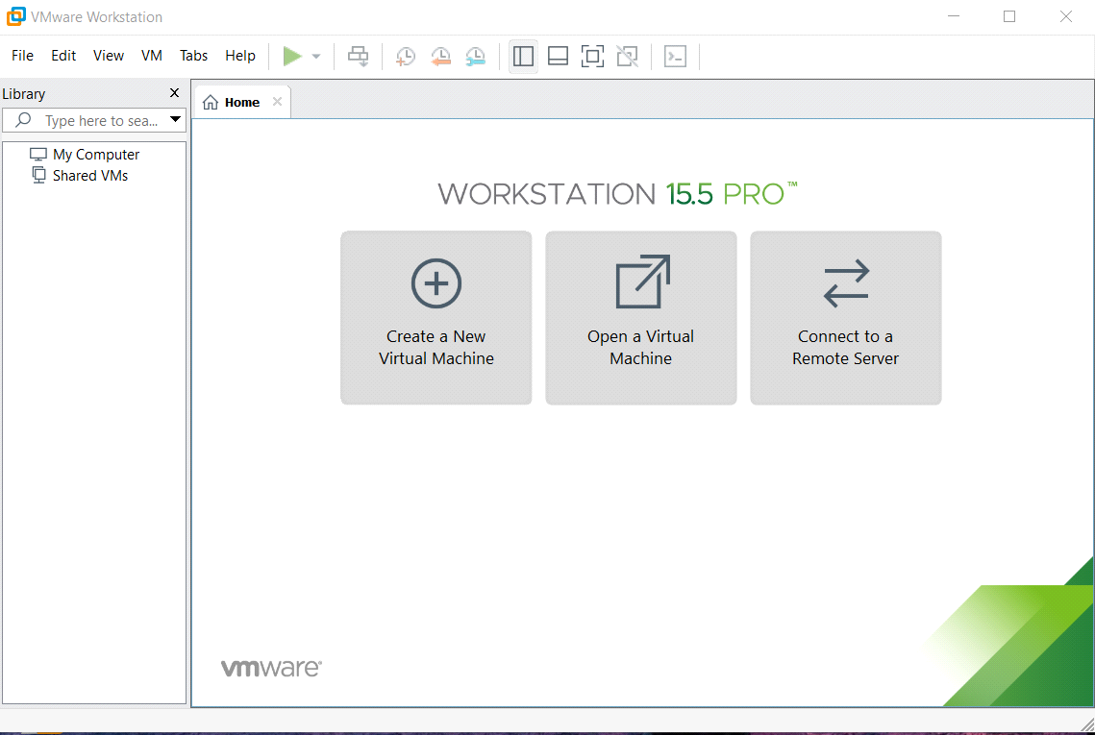

Then open up VMware workstation and select create a new virtual machine a prompt will open up asking what type of installation you want select custom(advanced)

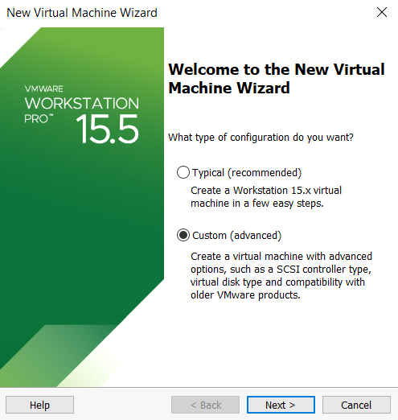

For the virtual machine hardware compatibility just hit next a screen asking where to install your iso from will appear afterwards

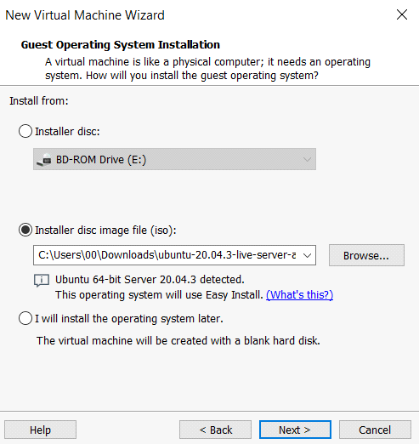

Next choose your username and password then proceed to customize your virtual machine to specifications it needs in terms of processing power and space if this confuses you go with the recommended settings VMware has set until you reach the network type screen

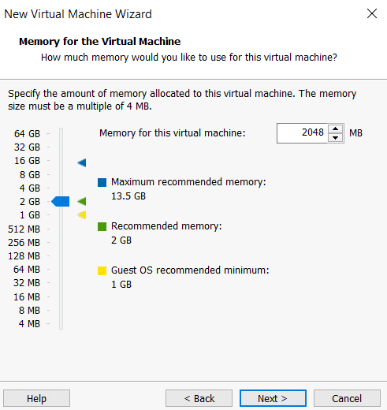

Once greeted by this choose if you want a network connection with the virtual machine then continue clicking next until you reach select a disk

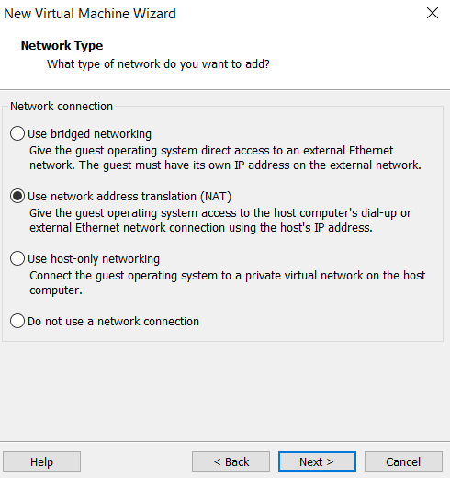

since this is a new instance you'll want to create a new virtual disk afterwards click next and choose the amount of space you want the vm to have and whether you want it split between files I'd recommend store as a single file due to easier management.

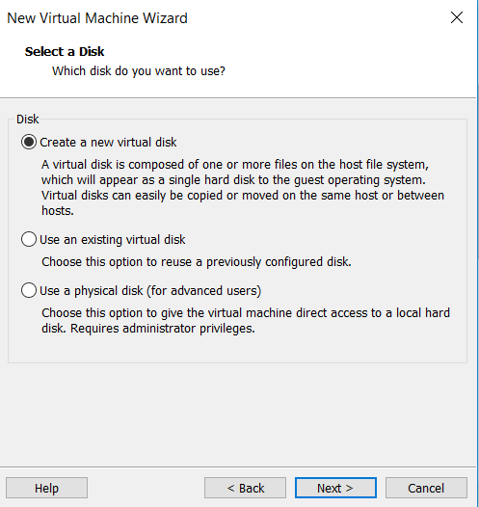

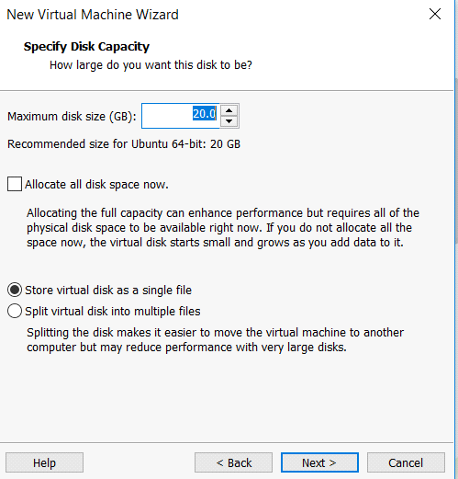

Then redo the process for the other iso you intend to install. After this step the similarities stop and become separate installation process.

**CentOS**

The install will begin with a black terminal with white text scrolling down let it continue until it brings you to this screen.

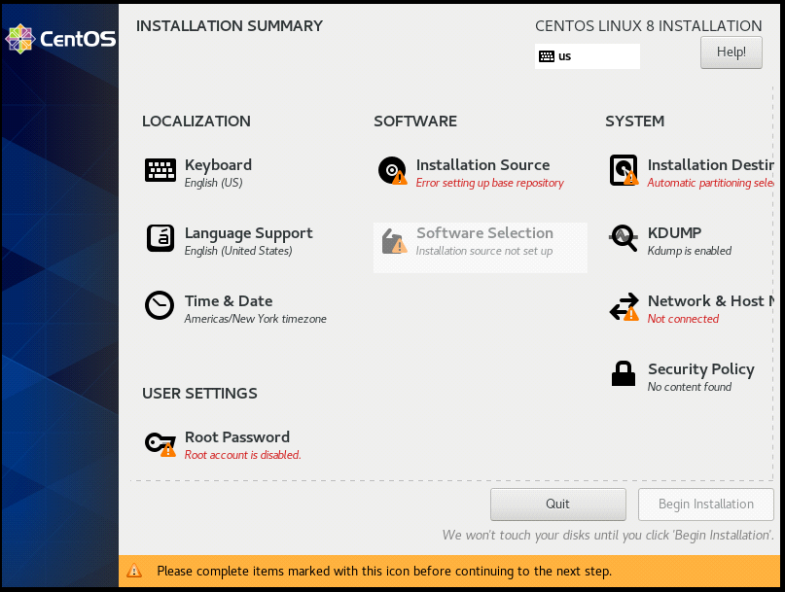

Once at this screen choose installation destination and choose your preferred storage afterwards hit done then go to network and host manager

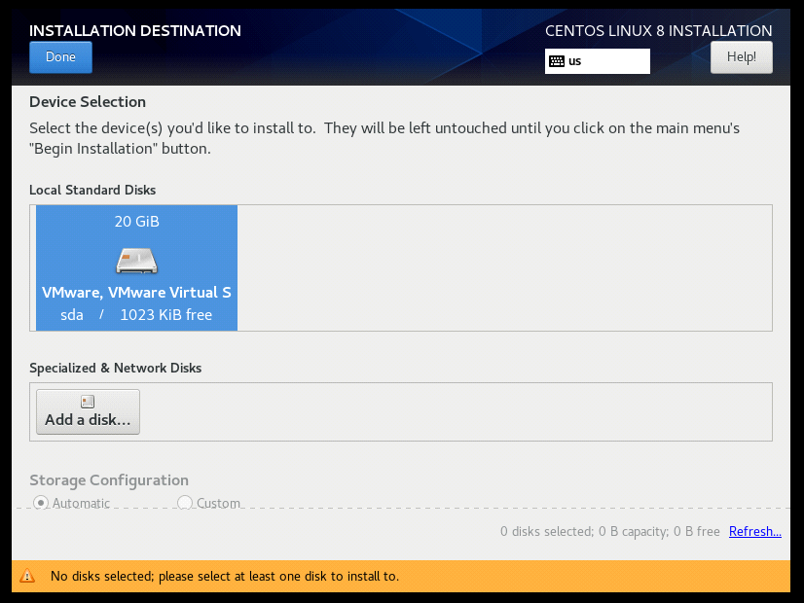

Toggle the on switch near the top right or tinker your network settings if you need to then click done and go back and wait until installation source error clears and hit software selection

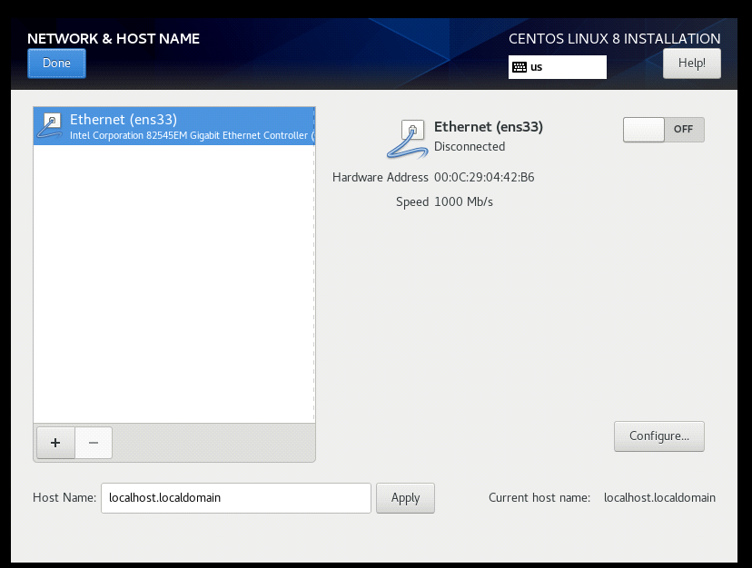

Once there choose server and any additional software you need if not leave it blank then hit done and scroll down underneath root password you should see user create a user and a root password then begin the installation

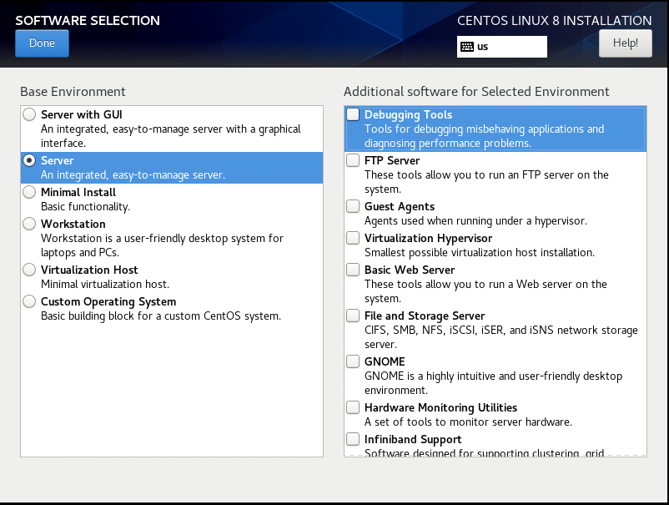

once done reboot the system and wait until it asks you to login

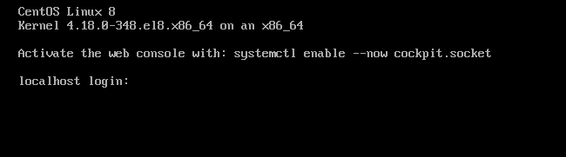

**Ubuntu server**

The installation starts asking for a language choose your desired language then proceed to network settings

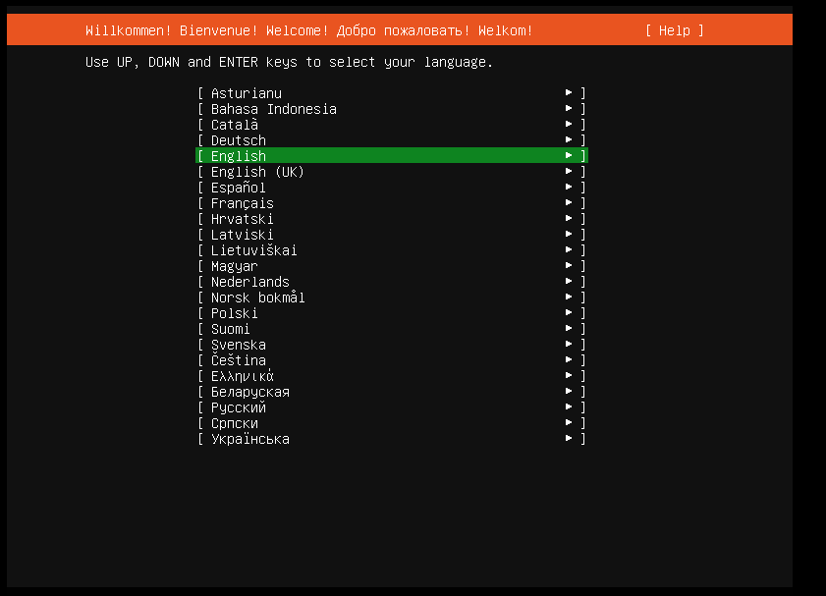

Once you have your network settings setup hit done and proceed to proxy

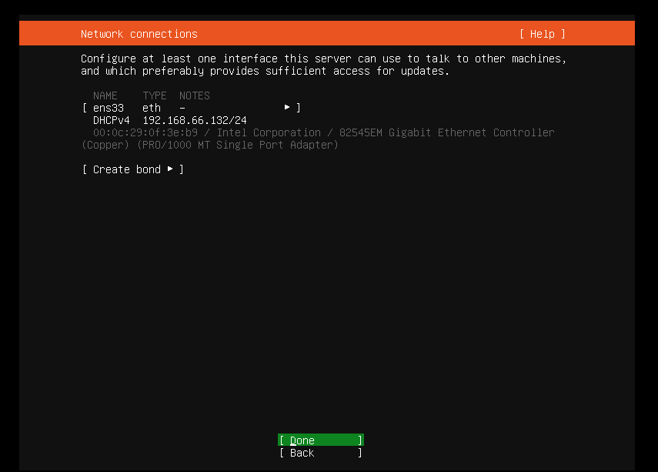

unless you have a proxy setup leave this blank then hit done and continue you can leave the ubuntu mirror as if and hit done again

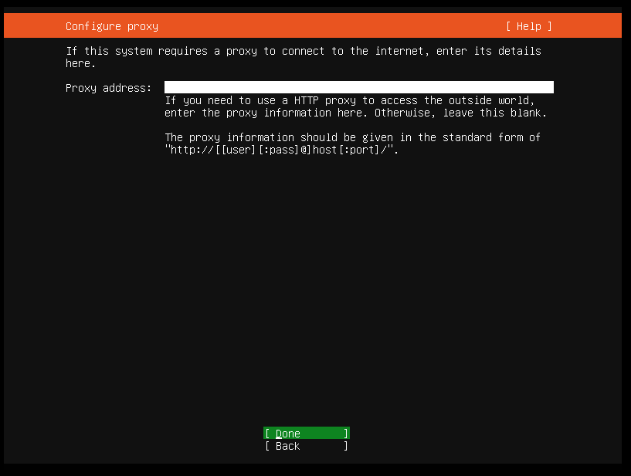

For storage it should already be setup but if you need to make changes do so and continue

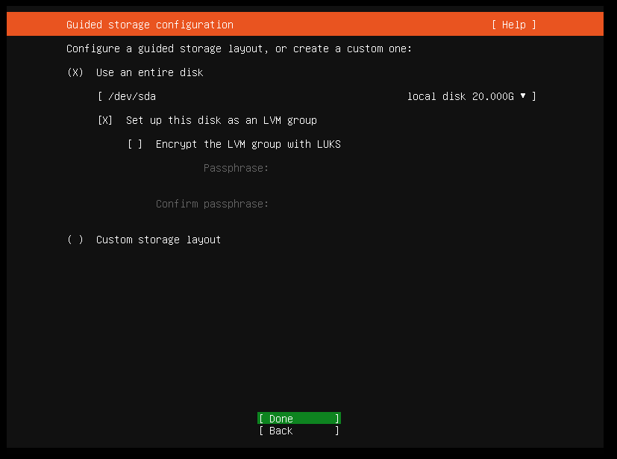

Now for the storage configuration leave it as it is and continue except this time after you hit done you will get a second prompt asking to confirm destructive action hit continue and proceed

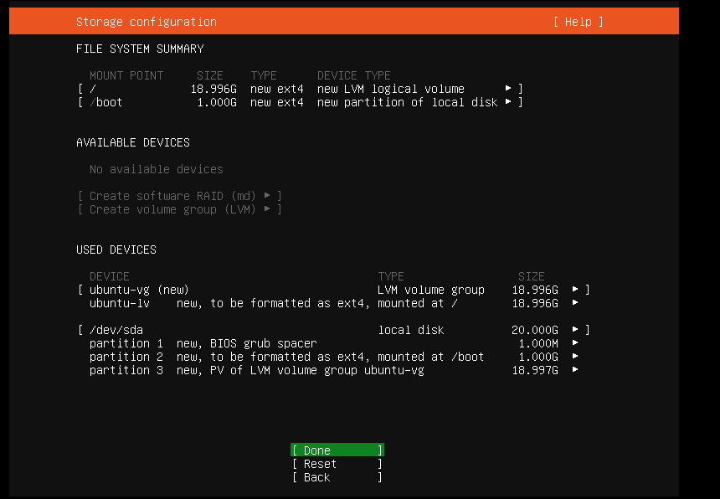

Setup the user whoever you like and proceed

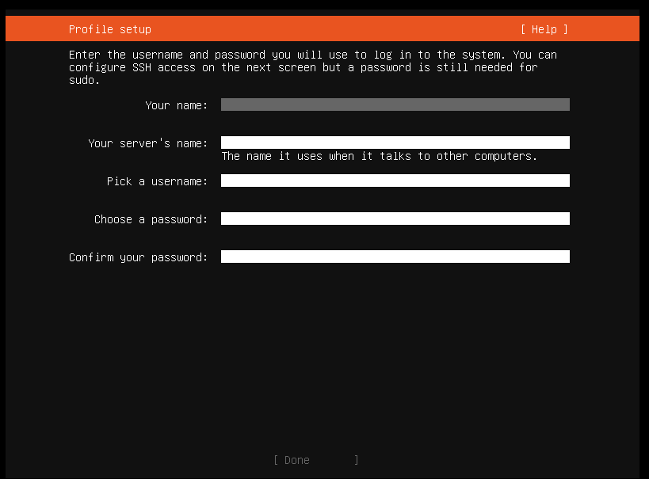

If you intend to use filesharing install ssh if not leave it be and proceed

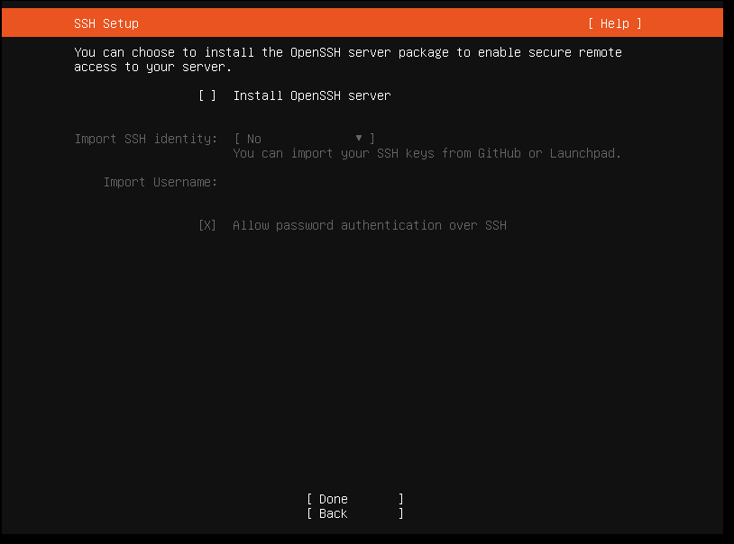

Once you get to server snaps leave it blank unless you intend to install any of the snaps then wait for the installation to complete then reboot and wait till it asks you to log in

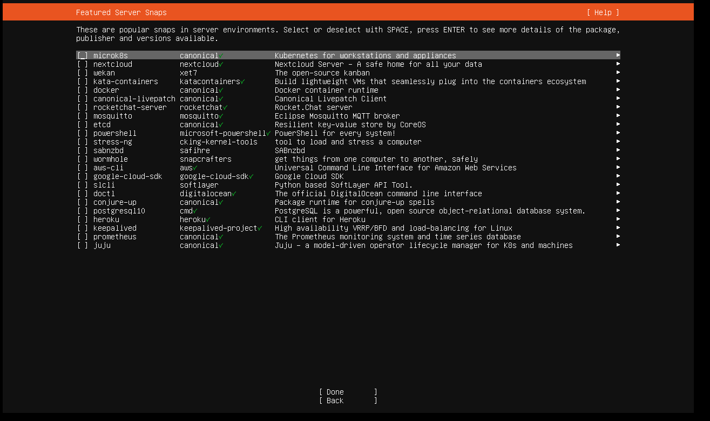

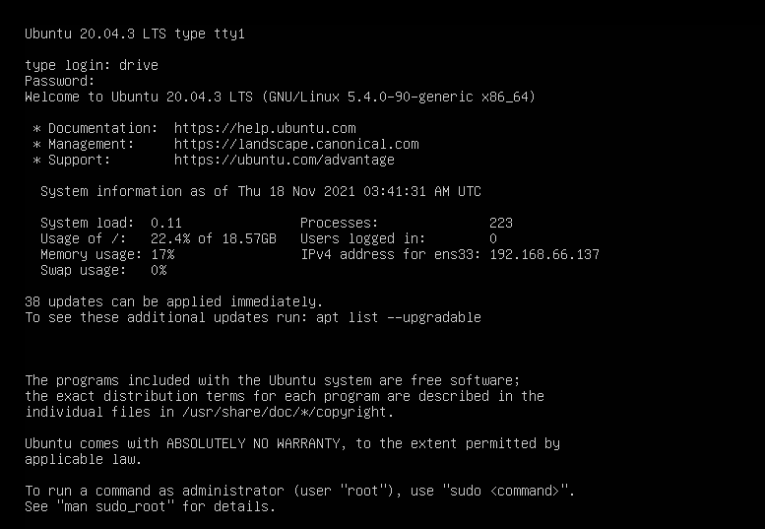

**File sharing**

Scp was the method I chose for file sharing

To use scp you’re going to need the name of the user and the ip try typing in ifconfig to grab the ip if it doesn’t work you'll have to install it with sudo apt install net-tools

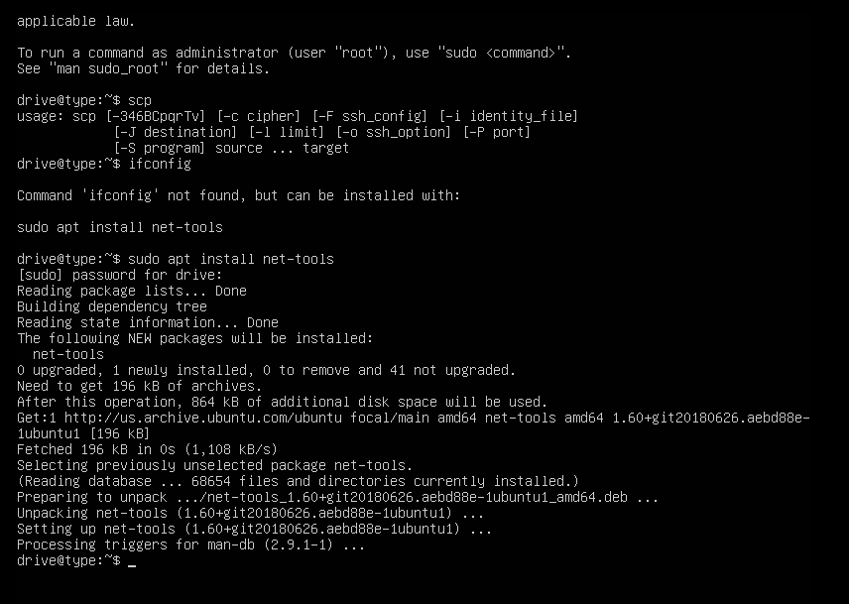

Afterwards choose the file you want to send over and make sure the command looks something like this scp car drive@192.168.66.135:/home/drive

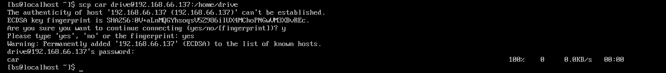

And if I ls in ubuntu the file will have successfully transferred

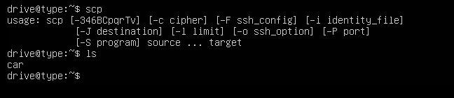

Asides from adding ssh and net tools in the ubuntu server I didn't add any other software to the basic install and kept it pretty vanilla.